# **This document explains the steps to configure Backup job and restore a repository in case the repository is corrupted or is deleted accidentally.**

Backup of all Repositories are taken care by Visual SVN Server Manager (Version 3.6.4)

**Configuration of Backup Job:**

1. Right Click on Jobs tab and select “Create Backup Job”

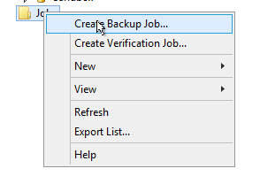

1. Enter the Job name and description.

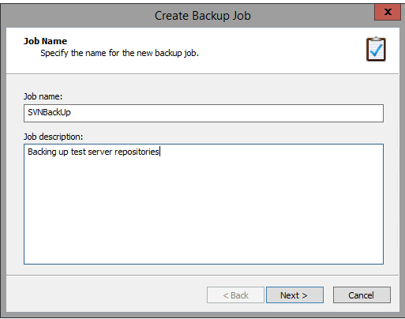

1. Click on All repositories to Backup.

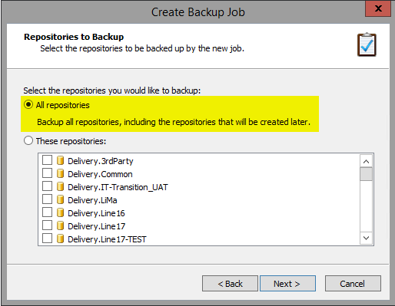

1. Enter the destination path where the repositories need to be backed up.

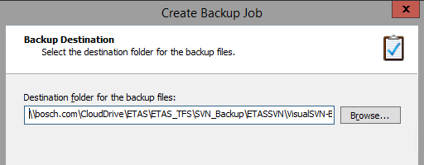

1. Select the type of Backup you need.

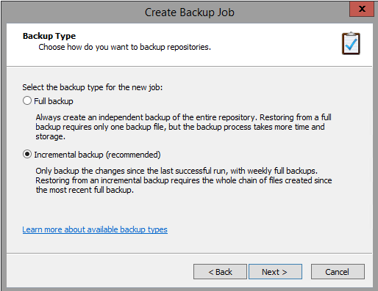

1. As the incremental backup is always done on a daily basis at 20:00 hrs. CET, and full back up is taken place every Friday.

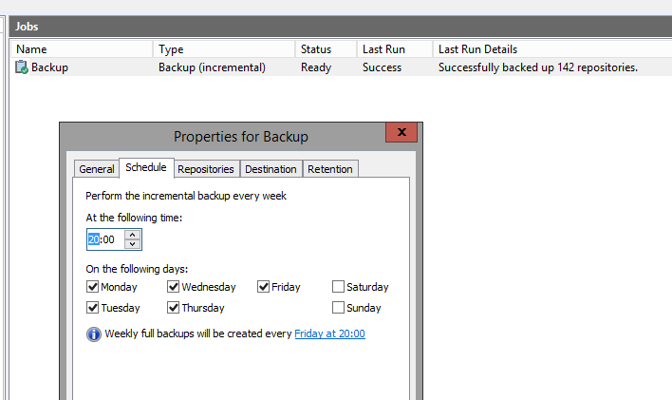

1. Select Backup retention policy to 7 days.

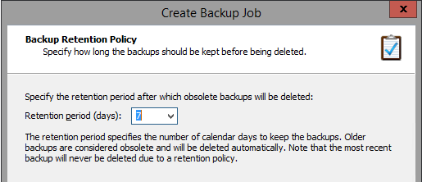

1. Click on Create.

The created scheduled task makes a backup of D:\data\Repositories folder into the back up location i.e. \\bosch.com\CloudDrive\ETAS\ETAS_TFS\SVN_Backup\ETASSVN\VisualSVN-Backup

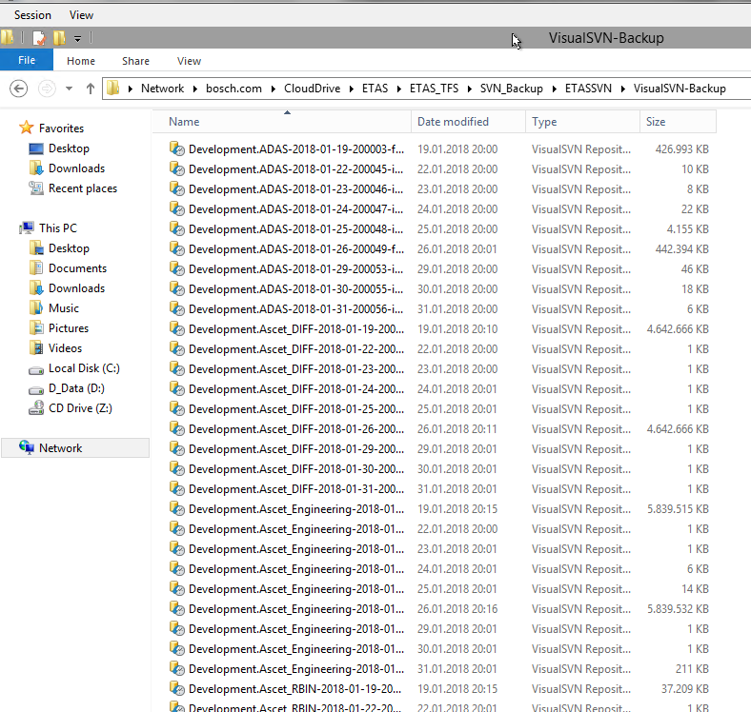

**Restoring repository from Backup**

To restore the repository from a backup via graphical management console, follow these steps:

1. Start VisualSVN Server Manager Console.
2. Right-click Repositories.

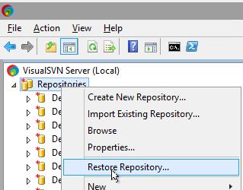

1. Click Restore Repository.
2. Select the Backup File name were the backup of these repositories are taken.

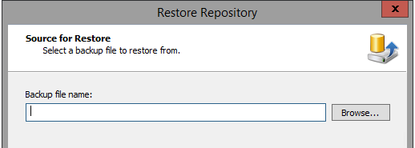

1. Select the Repository to be Restored.

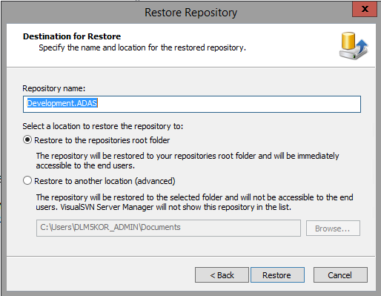

* If the repository is in corrupted state and still available in D:\data\Repositories then delete the repository from the above folder, if it is already deleted, then start restoring.
* Refresh the VisualSVN Server if you still do not see the repository.

